

ADDIS ABABA UNIVERSITY
FACULTY OF NATURAL AND COMPUTATIONAL
SCIENCES

DEPARTMENT OF COMPUTER SCIENCE

DENTIST APPOINTMENTS AND MANAGEMENT SYSTEM

CoSc4411: FINAL PROJCT BY

PROJECT ADVISOR: MR.ABDURHAMN

January 2026
DECLARATION
This is to declare that this project work which is done under the supervision of Mr.Abdurhamn and having the title Dentist Appointment And Management System
is the sole contribution of:

<<Group Members Here>>

No part of the project work has been reproduced illegally (copy and paste) which can be
considered as Plagiarism. All referenced parts have been used to argue the idea and have
been cited properly. We will be responsible and liable for any consequence if violation of this
declaration is proven.

Date: _____________________

Group Members:
Full Name Signature ________________________________ ___________________________________

CERTIFICATE
I certify that this BSc final project report entitled Dentist Appointment And Management System by:

<<list your name here>>

is approved by me for submission. I certify further that, to the best of my knowledge, the
report represents work carried out by the students.

_________________________ ____________________________________
Date Name and Signature of Supervisor

Table Of Content
List of tables vi
list of figures vii
CHAPTER ONE: INTRODUCTION 1
1.1 Problem Statement 2
1.2 Project Objectives 2
1.2.1 General Objective 2
1.2.2. Specific Objectives 2
1.3 Project Scope 3
1.4 Significance of the Study 3
1.5 Timeline 3
CHAPTER TWO: REQUIREMENT ANALYSIS 4
2.1 Introduction 4
2.2 Current System 4
2.2.1. Major Functions of the Current System / Current System Description 4
2.2.2. Problems of the Existing System 5
2.3 Requirement Gathering 5
2.3.1 Requirement Gathering Methodologies 5
2.3.2 Results Found 6
2.4 Proposed System 7
2.4.1 Overview 7
2.4.2 Functional Requirements 7
2.4.3 Non-Functional Requirements 8
2.5 Constraints / Pseudo Requirements 9
2.6 System Model 11
2.6.1 Use Case Model 12
2.6.2 Object Model 18
2.6.3 Dynamic Modeling 25
CHAPTER THREE: SYSTEM DESIGN 34
3.1 Introduction 34
3.2 Current Software Architecture 35
3.3 Proposed Software Architecture 35
3.3.1 Overview 36
3.3.2 Subsystem Decomposition 36
3.3.3 Hardware/Software Mapping 38
3.3.4 Persistent Data Management 40
3.3.5 Access Control and Security 41
3.3.6 Subsystem Services 42
3.4 Packages 42
3.4.1 Package Decomposition Overview 43
3.4.2 Package Descriptions and Responsibilities 43
3.4.3 Package Dependencies Summary 49
3.4.4 UML Package Diagram Representation 49
Conclusion 51
Recommendations and Future Enhancements 51
References 53
GLOSSARY 54

List of tables
Table 2.1 : Authenticate User 14
Table 2.2 : Manage Patient Account 14
Table 2.3 : Manage Appointment 15
Table 2.4 : View Dental Records 16
Table 2.5 : Manage Appointment Requests 16
Table 2.6 : Register Walk-in Patient 17
Table 2.7 : Manage Staff 18
Table 2.8 : User 19
Table 2.9 : Patient 19
Table 2.10 : Dentist 20
Table 2.11 : Receptionist 20
Table 2.12 : Appointment 20
Table 2.13 : DentalRecord 21
Table 2.14 : Prescription 21
Table 3.1 : Subsystem Services 42

list of figures
Figure 1.1 : Gantt Chart 3
Figure 2.1 : Use Case Diagram 12
Figure 2.2 : Class Diagram 24
Figure 2.3 : User Authentication Sequence Diagram 25
Figure 2.4 : Patient Registration Sequence Diagram 26
Figure 2.5 : Online Appointment Booking Sequence Diagram 27
Figure 2.6 : Appointment Approval by Dentist Sequence Diagram 28
Figure 2.7 : Walk-in Patient Registration Sequence Diagram 29
Figure 2.8 : Appointment Completion Sequence Diagram 30
Figure 2.9 : Staff Management (Admin) Sequence Diagram 31
Figure 2.10 : Online Appointment Booking Activity Diagram 32
Figure 2.11 : Walk-in Patient Registration Activity Diagram 33
Figure 2.12 : Appointment Approval & Scheduling (Dentist) Activity Diagram 33
Figure 3.1 : Subsystem Decomposition 38
Figure 3.2 : Hardware/Software Mapping 39
Figure 3.3 : Persistent Data Management 41
Figure 3.4 : Package Diagram 49

CHAPTER ONE: INTRODUCTION
Dentistry is a dental management system that make human life easier in the medical field. It automate the existing traditional manual system such as manual registration form. This project focuses on creating a digital system that helps patients easily book dentist appointments and manage their dental care in a simple and organized way. The system replaces the traditional paper-based and walk-in scheduling process, which usually leads to long waiting times, lost records, and poor communication between clinics and patients.
Dental health centers provide instruction on brushing, flossing, the use of fluorides, and other aspects of dental care. They remove tooth decay, fill cavities, examine X rays, place protective plastic sealants on children's teeth, straighten teeth, and repair fractured teeth. They also perform corrective surgery on gums and supporting bones to treat gum diseases. Dentists extract teeth and make models and measurements for dentures to replace missing teeth. They also administer anesthetics and write prescriptions for antibiotics and other medications.
Dental health centers are very significant because they provide crucial services to the patients, so it is necessary to automate their work process in order to enhance the quality of their service. Since most of our dental clinics work manual system, and it is very hard to keep track the health situation of the patients in an order manner with time to time. The platform allows patients to book appointments online, receive reminders, view their dental history, and communicate with the clinic. On the clinic’s side, dentists and staff can manage schedules, patient records, treatments, and follow-ups from one dashboard. Since many patients in Ethiopia rely on smartphones, the system is designed with a mobile-friendly interface to make it easy for a wide range of users.
The dental clinics requires a database system that solve patients dental problems to cure and visits their doctors/consultants more than one time, so the dentist have to follow up their treatment history properly to provide the best treatment type. Generally, the system aims to
modernize dental service delivery by reducing crowding, improving accuracy, and creating a smooth experience for both patients and dentists.

1.1 Problem Statement
Most dental clinics in Ethiopia rely on manual appointment booking and record keeping. Patients often have to visit the clinic physically just to check availability, which causes inconvenience, long queues, and unnecessary delays. Due to lack of reminders, many appointments are missed and wasting both patients’ time and the clinic’s resources.
Dental records are often stored on paper, making them easy to lose, hard to retrieve, and difficult to update. Communication between dentists and patients are limited, especially regarding follow-up visits, treatment plans, and emergency care. These challenges create frustration for patients, reduce clinic efficiency, and lead to inconsistent service. By developing new Dental Database System or digital dentist appointment and management system, these issues are addressed by introducing automated scheduling, organized record-keeping, securing information, and better communication tools.
Dentist can figure out the best treatment for the patient by viewing the past dental history that had been recorded before. So, to organize, keep save patient’s information and provide the best, appropriate treatments to the patients there must be a database system that stores the right information for every patient.

1.2 Project Objectives

1.2.1 General Objective
The general objective of the project is to design and develop a web-based dentist appointment and management system that streamlines patients scheduling

1.2.2. Specific Objectives
The specific objectives of the project are:
- To allow patients to book appointments online without visiting the clinic.
- To provide automated reminders for upcoming appointments
- To enable dentists to manage patient records, treatment history, and schedules digitally.
- To offer a dashboard for dental clinic to manage appointments, availability, and follow-ups.
- To provide a mobile-friendly interface so users can access the system easily on any device.

1.3 Project Scope
The project scope is determined in patient dental management system to fulfill all their needs such as registering the patients and capturing their data and retrieve back information. In addition, the project track dental record and information, online viewing the prescript and recommendation of dentist by automating the manual procedure, assisting online transaction and patient records.

1.4 Significance of the Study
The study on the Patient Dental Management System (PDMS) holds significant implications for multiple stakeholders, including patients, dental professionals, and healthcare institutions. The study automate the patient registration process, increase access for record and online prescriptions, patient information, and tracking dental histories to reduce waiting times and enhances the initial experience. In addition, it helps to make better clinical decisions and follow-up by having easy access to comprehensive patient histories and recommendations. The beneficiaries of the project are patients, medical staffs, clinic owners, local communities and government.

1.5 Timeline
Figure 1.1: Gantt Chart
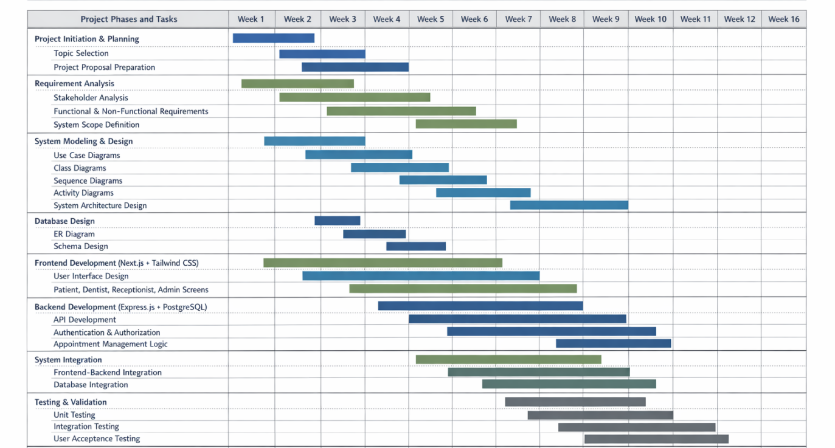

CHAPTER TWO: REQUIREMENT ANALYSIS

2.1 Introduction
Requirement analysis is a critical phase in the software development life cycle that focuses on identifying, analyzing, and documenting the functional and non-functional requirements of the proposed system. This phase ensures that the developed system meets the actual needs of users and stakeholders while addressing existing problems in the current operational environment.
The purpose of the Dentist Appointments and Management System is to design and implement a web-based system that automates and manages dental clinic operations in a private dental clinic setting in Ethiopia. The system aims to improve appointment scheduling, patient record management, communication between patients and clinic staff, and overall clinic efficiency through the use of modern web technologies.
The system is intended to replace or enhance the traditional manual processes commonly used in Ethiopian dental clinics, such as paper-based patient records, face-to-face appointment booking, and manual queue management. By digitizing these processes, the system seeks to reduce operational inefficiencies, minimize human error, improve service delivery, and enhance patient satisfaction.

2.2 Current System
Most private dental clinics in Ethiopia currently rely on manual or semi-manual systems to manage their daily operations. These systems are heavily dependent on paper records, physical appointment books, and verbal communication among clinic staff, dentists, and patients.

2.2.1. Major Functions of the Current System / Current System Description
The major functions of the existing system include:
- Patient information is recorded manually using paper files during the first visit.
- Appointments are booked in person or through phone calls and recorded in a physical appointment logbook.
- Dentists maintain patient dental histories manually in paper folders.
- Prescriptions and treatment notes are handwritten.
- Receptionists manage patient queues verbally or through simple written lists.
- Follow-up visits are scheduled verbally without automated reminders.
- Reports and statistics, if required, are prepared manually by reviewing physical records.

Although this system has been in use for many years, it is increasingly becoming insufficient to handle the growing number of patients and the need for accurate and efficient service delivery.

2.2.2. Problems of the Existing System
The current manual system suffers from several limitations, including but not limited to:
- Inefficiency and Time Consumption: Manual appointment booking and record searching consume significant time for both patients and clinic staff.
- Data Loss and Damage: Paper-based records are vulnerable to loss, damage, and misplacement.
- Poor Record Management: Retrieving patient history or treatment details is difficult and slow.
- Appointment Conflicts: Overbooking, double-booking, and missed appointments are common due to lack of real-time scheduling.
- Lack of Patient Notifications: Patients are not reminded of upcoming appointments, leading to high no-show rates.
- Limited Accessibility: Patient records can only be accessed physically at the clinic.
- Poor Reporting Capability: Generating statistical or analytical reports is difficult and unreliable.
- Security Issues: Sensitive patient information is not adequately protected from unauthorized access.
These challenges highlight the need for a modern, automated system that can effectively support dental clinic operations.

2.3 Requirement Gathering
Requirement gathering is the process of collecting detailed information about system needs from stakeholders to ensure the proposed system aligns with real-world clinic workflows and expectations.

2.3.1 Requirement Gathering Methodologies
The following requirement gathering methodologies were considered and applied during the analysis phase:
- Interviews
Informal interviews were conducted with dental clinic staff, including receptionists and dentists, to understand daily workflows, challenges, and expectations from a computerized system.
- Observation
Observation of clinic operations was used to study patient flow, appointment handling, queue management, and record-keeping practices.
- Document Review
Existing paper-based forms such as patient registration sheets, appointment books, and prescription formats were reviewed to understand current data requirements.
- Literature Review
Academic articles, similar health management systems, and best practices in clinic management systems were reviewed to identify standard features and system behaviors.
- Stakeholder Analysis
Key stakeholders such as patients, dentists, receptionists, and clinic administrators were identified to ensure that the system addresses the needs of all user roles.

2.3.2 Results Found
Based on the requirement gathering process, the following results were identified:
- There is a strong need for an online appointment booking system to reduce waiting time and appointment conflicts.
- Clinics require a centralized patient database to store and retrieve patient information efficiently.
- Dentists need access to complete dental history, diagnosis, and treatment records.
- Receptionists require tools to manage walk-in patients, appointment schedules, and patient queues.
- Clinic administrators need a dashboard and reporting tools to monitor clinic performance.
- Patients expect transparent appointment status and access to their dental records.
- Security and privacy of patient data are critical due to the sensitive nature of medical information.
- The system must be simple, reliable, and accessible given varying levels of technical literacy.
These findings formed the basis for defining the functional and non-functional requirements of the proposed Dentist Appointments and Management System.

2.4 Proposed System

2.4.1 Overview
The proposed system is a web-based Dentist Appointments and Management System designed to automate and streamline the core operations of a private dental clinic in Ethiopia. The system aims to replace the existing manual and paper-based processes with a secure, centralized, and efficient digital platform accessible to patients, dentists, receptionists, and clinic administrators.
The system will allow patients to register, book appointments, view dental records, and receive notifications. Dentists will be able to manage schedules, access patient histories, record diagnoses, and issue digital prescriptions. Receptionists will assist in managing walk-in patients, appointment coordination, and queue management. Clinic administrators will oversee clinic operations through dashboards, staff management tools, and configuration settings.
The proposed system is developed using modern web technologies, including Next.js for the frontend, Express.js for backend services, and PostgreSQL for database management. The system is designed to be scalable, secure, and adaptable to future enhancements such as online payments, advanced reporting, and integration with external health systems.

2.4.2 Functional Requirements
The following are the high-level functional requirements of the system, categorized by user roles:

Patient Functional Requirements
- Register and manage personal profile information.
- log in and log out of the system.
- View available dentists and appointment time slots.
- Book, cancel, or reschedule appointments online.
- Receive in-app notifications and reminders.

Dentist Functional Requirements
- Securely log in to the system.
- Manage personal profile and availability.
- View daily and weekly appointment schedules.
- Accept or reject appointment requests.
- Access and update patient dental records.
- Mark appointments as completed.

Receptionist / Clinic Staff Functional Requirements
- Register walk-in patients into the system.
- Search and update basic patient information.
- Book and modify appointments on behalf of patients.
- Coordinate between patients and dentists for scheduling.

Clinic Administrator Functional Requirements
- Manage dentist and receptionist user accounts.
- Assign working hours and availability for dentists.
- View statistics on appointments

System Functional Requirements
- Provide role-based access control.
- Automatically update appointment statuses.
- Support search and filtering of patients and appointments.

2.4.3 Non-Functional Requirements

2.4.3.1 Hardware Consideration
The system is designed to run on standard computer hardware commonly available in Ethiopian private clinics. Hardware requirements include:
- Desktop or laptop computers with modern web browsers.
- Internet connectivity for online access.
- Optional printers for printing prescriptions or reports.
The system does not require specialized medical hardware integration at the current stage, but it allows future integration with imaging devices if required.

2.4.3.2 Performance Characteristics
The system shall provide acceptable performance under normal and peak usage conditions. Performance requirements include:
- Fast page loading and response times.
- Support for multiple concurrent users (patients, staff, and dentists).
- Efficient database query handling.
- Ability to handle peak loads during busy clinic hours.
The system is designed to handle small to medium-sized private clinics with moderate patient traffic.

2.4.3.3 Security Issues
Security is a critical requirement due to the sensitivity of medical data. The system shall implement:
- Role-based access control.
- Secure authentication mechanisms.
- Password hashing and session management.
- Data protection against unauthorized access.
These measures ensure compliance with data privacy and ethical standards.

2.5 Constraints / Pseudo Requirements
Constraints, also referred to as pseudo requirements, represent real-world limitations and conditions that may affect the development, deployment, and operation of the proposed Dentist Appointments and Management System. These constraints do not define system functionality directly, but they influence design decisions, implementation approaches, and overall system behavior.
The following constraints have been identified based on the operational environment of private dental clinics in Ethiopia:

1. Internet Connectivity Constraints
Although the system is web-based, internet connectivity in some areas of Ethiopia may be unstable or limited. This constraint affects system availability and responsiveness.
- The system must be designed to tolerate temporary network interruptions.
- Critical operations such as appointment booking and record updates should handle failures gracefully.
- The system should avoid unnecessary network requests and minimize bandwidth usage.

2. Power Supply Limitations
Power interruptions are a common challenge in many regions.
- The system should ensure data consistency during unexpected shutdowns.
- Transactions must be handled securely to prevent data corruption.
- The system should allow quick recovery once power is restored.

3. User Technical Literacy
Users of the system, including patients and clinic staff, may have varying levels of computer and internet proficiency.
- The system interface must be simple and intuitive.
- Complex workflows should be minimized.
- Clear error messages and confirmations should be provided.

4. Financial Constraints of Clinics
Most private dental clinics operate with limited financial resources.
- The system should be cost-effective to deploy and maintain.
- It should rely on widely supported, open-source technologies.
- Advanced features such as online payments may be deferred to future phases.

5. Legal and Ethical Constraints
Medical systems must respect patient privacy and data confidentiality.
- Patient information must be protected from unauthorized access.
- Data handling must follow ethical standards for medical records.
- Access to sensitive data must be restricted based on user roles.

6. Scalability Constraints
The system is initially intended for small to medium-sized private dental clinics.
- The system is not required to handle nationwide-scale usage.
- Scalability should be planned, but excessive infrastructure costs should be avoided.
- System performance should remain stable as the number of users grows gradually.

7. Hardware Availability
Clinics may use older or lower-specification computers.
- The system must function on standard desktop or laptop computers.
- It must not require high-end hardware or specialized devices.
- Browser compatibility must be ensured.

8. Change Management Constraints
Clinic staff may resist sudden changes from manual systems to digital platforms.
- The system should closely mirror existing workflows.
- Training requirements should be minimal.
- Gradual adoption should be supported.

9. Data Migration Constraints
Existing patient records are mostly paper-based.
- Initial data entry may be manual and time-consuming.
- The system should allow gradual digitization of records.
- Bulk data migration is not mandatory at the initial stage.

10. Time Constraints for Development
As an academic final-year project, development time is limited.
- The system must prioritize core functionalities.
- Advanced and optional features may be implemented as future enhancements.
- The scope must remain realistic and achievable within the academic timeline.

2.6 System Model
The system model describes the structure and behavior of the proposed Dentist Appointments and Management System using standardized software engineering modeling techniques. It provides a conceptual representation of how different system components interact with each other and how users engage with the system to achieve specific goals.
The system model helps in visualizing the system from multiple perspectives, including functional behavior, object relationships, dynamic interactions, and user interface flow. This section serves as a bridge between requirement analysis and system design by transforming requirements into structured models such as scenarios, use case models, object models, and interaction diagrams.

2.6.1 Use Case Model
The Use Case Model represents the functional requirements of the proposed web-based dental clinic management system by illustrating how different users interact with the system. It provides a clear, user-centric view of the system’s behavior by identifying system actors and the use cases they perform. This model helps stakeholders understand system functionality at a high level and serves as a foundation for system design, implementation, and testing. The use case model ensures that all functional requirements identified during requirement analysis are properly captured and aligned with real-world clinic operations.

2.6.1.1 Use Case Diagram
Figure 2.1: Use Case Diagram

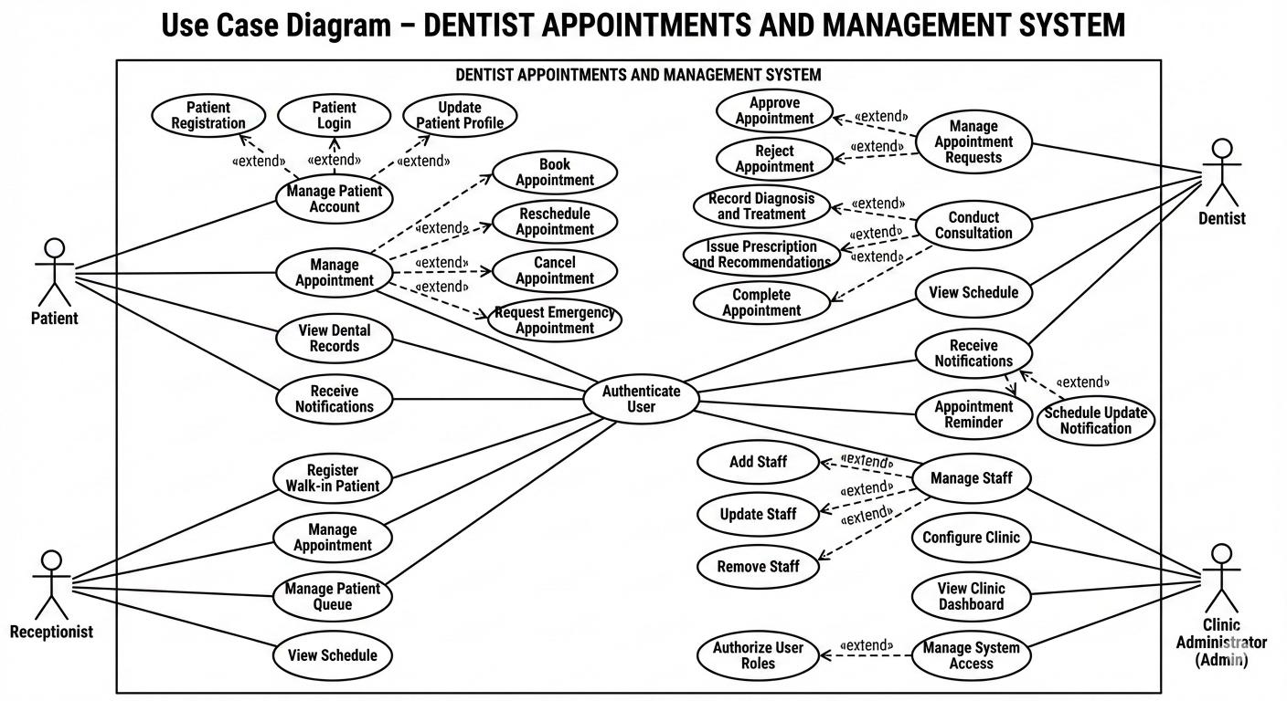

2.6.1.2 Description of Use-Case Model
Table 2.1: Authenticate User
Field | Description
Use Case ID | UC-01
Use Case Name | Authenticate User
Primary Actors | Patient, Dentist, Receptionist, Clinic Administrator
Description | This use case allows users to securely authenticate themselves into the system using valid credentials before accessing authorized functionalities.
Preconditions | The user must have a registered account in the system.
Postconditions | The user is successfully logged into the system and granted access based on assigned role permissions.
Main Flow | - User navigates to the login page.  - User enters valid credentials.  - System validates credentials.  - System grants access and redirects user to their dashboard.
Alternative Flow | 3a. Invalid credentials are entered.  3b. System displays an error message and requests retry.
Related Use Cases | Extended by role-based authorization

Table 2.2: Manage Patient Account
Field | Description
Use Case ID | UC-02
Use Case Name | Manage Patient Account
Primary Actor | Patient
Description | This use case enables patients to create, access, and manage their personal accounts within the system.
Preconditions | The system must be available.
Postconditions | Patient account information is created, updated, or accessed successfully.
Main Flow | - Patient selects account management option.  - System displays account options.  - Patient performs the required action.  - System saves and confirms changes.
Alternative Flow | 3a. Patient cancels the operation.  3b. System discards changes and returns to dashboard.
Extended Use Cases | Patient Registration, Patient Login, Update Patient Profile

Table 2.3: Manage Appointment
Field | Description
Use Case ID | UC-03
Use Case Name | Manage Appointment
Primary Actors | Patient, Receptionist
Description | This use case allows patients or receptionists to manage appointment-related activities including booking, rescheduling, or cancellation.
Preconditions | User must be authenticated.
Postconditions | Appointment information is successfully updated in the system.
Main Flow | - User selects appointment management option.  - System displays available dentists and time slots.  - User confirms appointment action.  - System records the appointment details.
Alternative Flow | 3a. Selected time slot becomes unavailable.  3b. System prompts user to choose another slot.
Extended Use Cases | Book Appointment, Reschedule Appointment, Cancel Appointment, Request Emergency Appointment

Table 2.4: View Dental Records
Field | Description
Use Case ID | UC-04
Use Case Name | View Dental Records
Primary Actor | Patient
Description | This use case allows patients to view their historical dental records including past visits, treatments, and prescriptions.
Preconditions | Patient must be authenticated.
Postconditions | Dental records are displayed to the patient.
Main Flow | - Patient navigates to dental records section.  - System retrieves patient records.  - System displays records in a readable format.
Alternative Flow | 2a. No records are found.  2b. System displays an appropriate message.
Related Use Cases | Conduct Consultation

Table 2.5: Manage Appointment Requests
Field | Description
Use Case ID | UC-06
Use Case Name | Manage Appointment Requests
Primary Actor | Dentist
Description | This use case allows dentists to review, approve, or reject appointment requests submitted by patients or receptionists.
Preconditions | Dentist must be authenticated and have assigned availability.
Postconditions | Appointment request status is updated and communicated to the patient.
Main Flow | - Dentist logs into the system.  - Dentist views pending appointment requests.  - Dentist approves or rejects a request.  - System updates appointment status and notifies the patient.
Alternative Flow | 3a. Dentist requests rescheduling.  3b. System sends rescheduling suggestion to the patient.
Extended Use Cases | Approve Appointment, Reject Appointment

Table 2.6: Register Walk-in Patient
Field | Description
Use Case ID | UC-09
Use Case Name | Register Walk-in Patient
Primary Actor | Receptionist
Description | This use case allows the receptionist to register patients who arrive at the clinic without prior online registration.
Preconditions | Receptionist must be authenticated.
Postconditions | Walk-in patient is registered and assigned a patient profile.
Main Flow | - Receptionist selects walk-in registration option.  - Receptionist enters patient basic information.  - System validates and stores the information.  - Patient profile is created successfully.
Alternative Flow | 2a. Patient already exists in the system.  2b. System retrieves existing patient record.
Related Use Cases | Manage Appointment, Manage Patient Queue

Table 2.7: Manage Staff
Field | Description
Use Case ID | UC-11
Use Case Name | Manage Staff
Primary Actor | Clinic Administrator
Description | This use case allows the clinic administrator to add, update, or remove dentist and receptionist accounts and manage their roles and availability.
Preconditions | Administrator must be authenticated with administrative privileges.
Postconditions | Staff records are successfully created, updated, or removed from the system.
Main Flow | - Administrator accesses staff management section.  - Administrator adds or modifies staff information.  - System validates the changes.4. System saves staff records.
Alternative Flow | 3a. Invalid staff data is entered.  3b. System displays validation error messages.
Related Use Cases | Manage System Access, View Clinic Dashboard

2.6.2 Object Model
The Object Model describes the static structure of the system by identifying the main objects (entities), their attributes, and the relationships among them. It provides a clear understanding of how data is represented, stored, and manipulated within the Dentist Appointment and Management System.
In this project, the object model is derived from the system’s functional requirements and use-case analysis. The identified objects represent real-world entities in a private dental clinic environment in Ethiopia, such as patients, dentists, appointments, and medical records. This model serves as the foundation for database design, class diagrams, and system implementation.

2.6.2.1 Data Dictionary
The data dictionary defines the core entities, their attributes, data types, and brief descriptions. These entities are used throughout the system to support appointment management, patient records, clinic operations, and system security.
Table 2.8: User
Attribute Name | Data Type | Description
userId | Integer | Unique identifier for each user
fullName | String | Full name of the user
email | String | User email address
phoneNumber | String | User phone number
passwordHash | String | Encrypted user password
role | Enum | User role (Patient, Dentist, Receptionist, Admin)
profilePhoto | String | Path or URL to profile photo
status | Boolean | Indicates whether the account is active
createdAt | DateTime | Account creation date

Table 2.36: Patient
Table 2.9: Patient
Attribute Name | Data Type | Description
patientId | Integer | Unique patient identifier
userId | Integer (FK) | References User
age | Integer | Patient age
gender | String | Patient gender
address | String | Patient residential address
emergencyContact | String | Emergency contact information

Table 2.10: Dentist
Attribute Name | Data Type | Description
dentistId | Integer | Unique dentist identifier
userId | Integer (FK) | References User
specialization | String | Dental specialization
licenseNumber | String | Professional license number
availability | String | Available working hours
yearsOfExperience | Integer | Professional experience in years

Table 2.11: Receptionist
Attribute Name | Data Type | Description
receptionistId | Integer | Unique receptionist identifier
userId | Integer (FK) | References User
shift | String | Assigned working shift

Table 2.12: Appointment
Attribute Name | Data Type | Description
appointmentId | Integer | Unique appointment identifier
patientId | Integer (FK) | References Patient
dentistId | Integer (FK) | References Dentist
appointmentDate | Date | Scheduled appointment date
appointmentTime | Time | Scheduled appointment time
status | Enum | Pending, Approved, Completed, Cancelled
isEmergency | Boolean | Indicates emergency appointment
createdAt | DateTime | Booking date

Table 2.13: DentalRecord
Attribute Name | Data Type | Description
recordId | Integer | Unique dental record identifier
patientId | Integer (FK) | References Patient
dentistId | Integer (FK) | References Dentist
diagnosis | Text | Diagnosis details
treatment | Text | Treatment performed
notes | Text | Additional clinical notes
visitDate | Date | Date of consultation

Table 2.14: Prescription
Attribute Name | Data Type | Description
prescriptionId | Integer | Unique prescription identifier
recordId | Integer (FK) | References DentalRecord
medicineName | String | Name of prescribed medicine
dosage | String | Dosage instructions
duration | String | Treatment duration
remarks | Text | Additional recommendations

2.6.2.2 Class Modeling
Class modeling represents the static structure of the system by defining system classes, their attributes, operations, and the relationships among them. It transforms the conceptual object model into a design-level representation that directly supports system implementation.
In the Dentist Appointment and Management System, class modeling is used to illustrate how real-world clinic entities—such as users, appointments, dental records, and clinic configurations—interact within the system. The class diagram provides a blueprint for database schema design and object-oriented implementation using technologies such as Next.js, Express.js, and PostgreSQL.

Identified Core Classes
The following core classes are identified from the requirement analysis and use-case model:
- User
- Patient
- Dentist
- Receptionist
- Admin
- Appointment
- DentalRecord
- Prescription
- Notification
- ClinicConfiguration
- Queue

Class Relationships Description
- Inheritance Relationship
- The User class is the superclass.
- Patient, Dentist, Receptionist, and Admin inherit from User.
- This supports role-based access control, a core security requirement.
- Association Relationships
- A Patient books one or more Appointments.
- A Dentist handles multiple Appointments.
- A Dentist creates DentalRecords for patients.
- A DentalRecord contains one or more Prescriptions.
- A User receives multiple Notifications.
- Aggregation Relationships
- ClinicConfiguration aggregates system-wide operational settings.
- Queue aggregates appointment flow data for daily operations.
- Cardinality Summary
- One Patient → Many Appointments
- One Dentist → Many Appointments
- One Appointment → One DentalRecord
- One DentalRecord → Many Prescriptions
- One User → Many Notifications

Design Considerations
- The class structure supports scalability, allowing future integration of online payments and government reporting modules.
- The inheritance model minimizes redundancy and improves maintainability.
- Relationships reflect realistic workflows in Ethiopian private dental clinics, such as receptionist-assisted appointments and walk-in registration.
- Classes are designed to map cleanly to relational tables in PostgreSQL.
Figure 2.2: Class Diagram
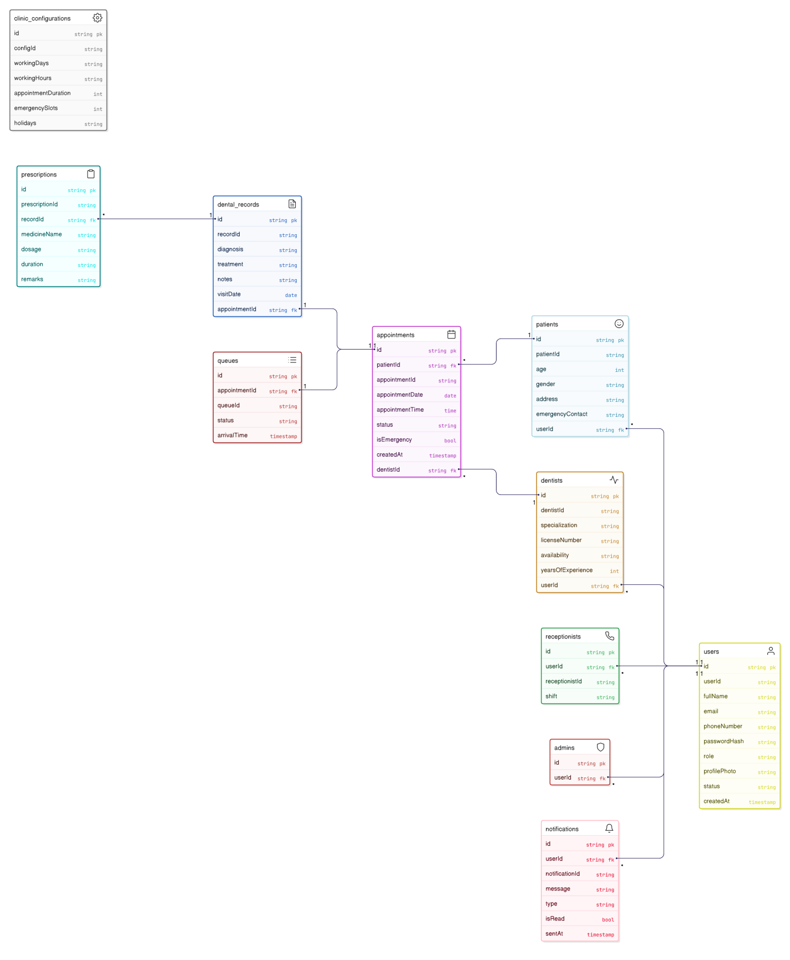

2.6.3 Dynamic Modeling
Dynamic modeling describes the runtime behavior of the system by illustrating how system components interact over time to fulfill specific use cases. Unlike the object model, which focuses on structure, dynamic modeling emphasizes message flow, sequencing, and state changes among actors and system components.
In the Dentist Appointment and Management System, dynamic modeling is represented using sequence diagrams to capture critical workflows such as authentication, appointment management, consultation, and clinic administration. These diagrams are derived directly from the scenario and use-case analysis and reflect real operational processes in a private dental clinic environment in Ethiopia.
Figure 2.3: User Authentication Sequence Diagram
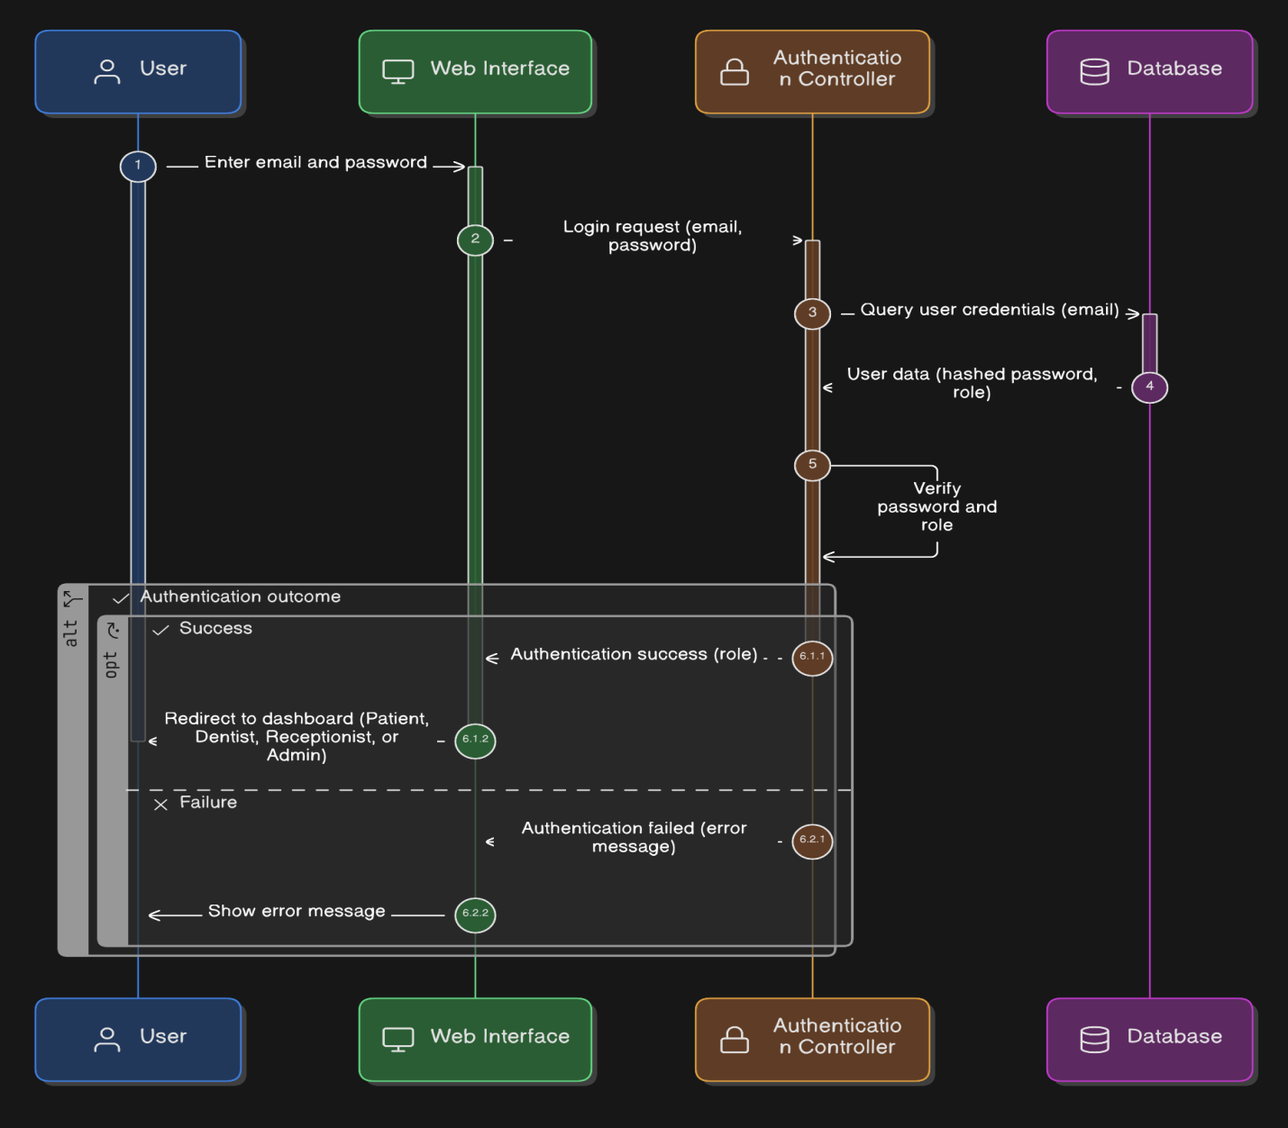

Figure 2.4: Patient Registration Sequence Diagram
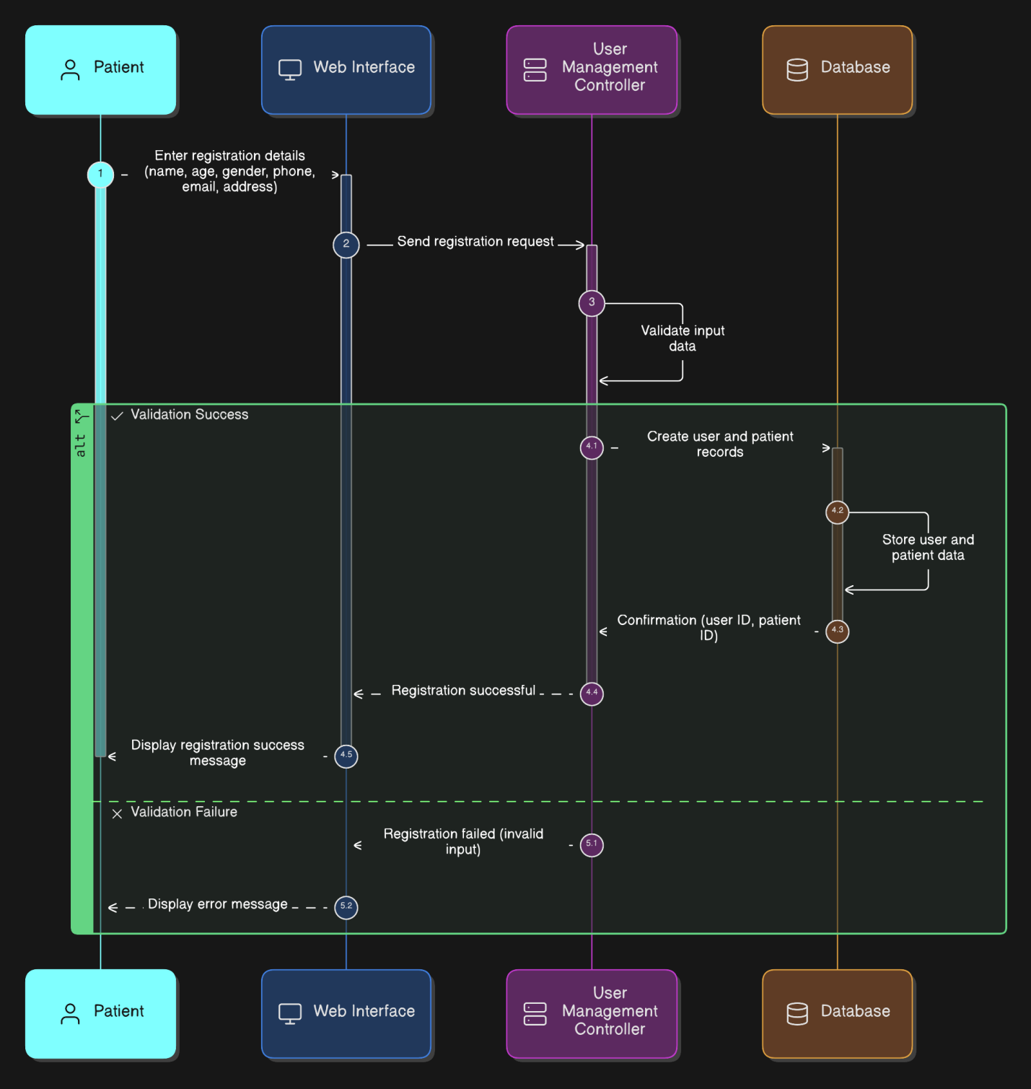

Figure 2.5: Online Appointment Booking Sequence Diagram
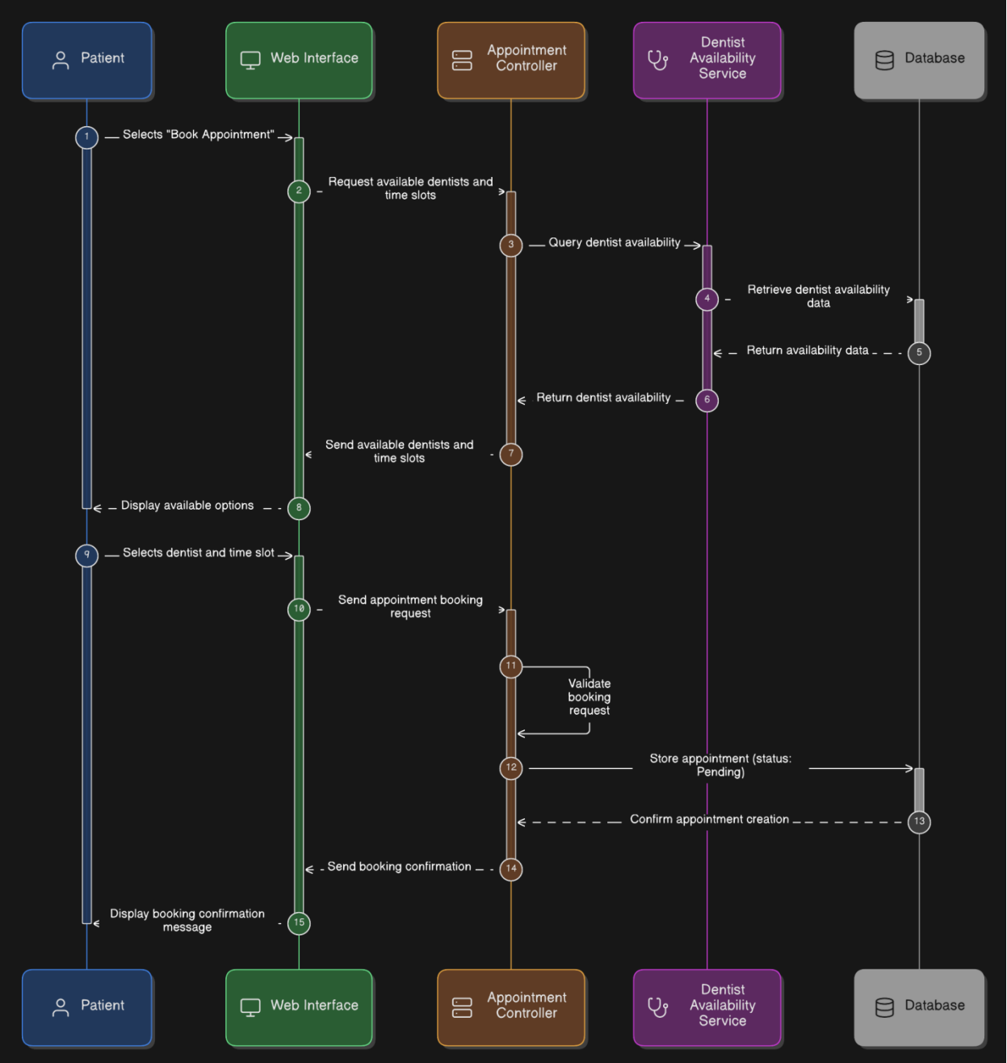

Figure 2.6: Appointment Approval by Dentist Sequence Diagram
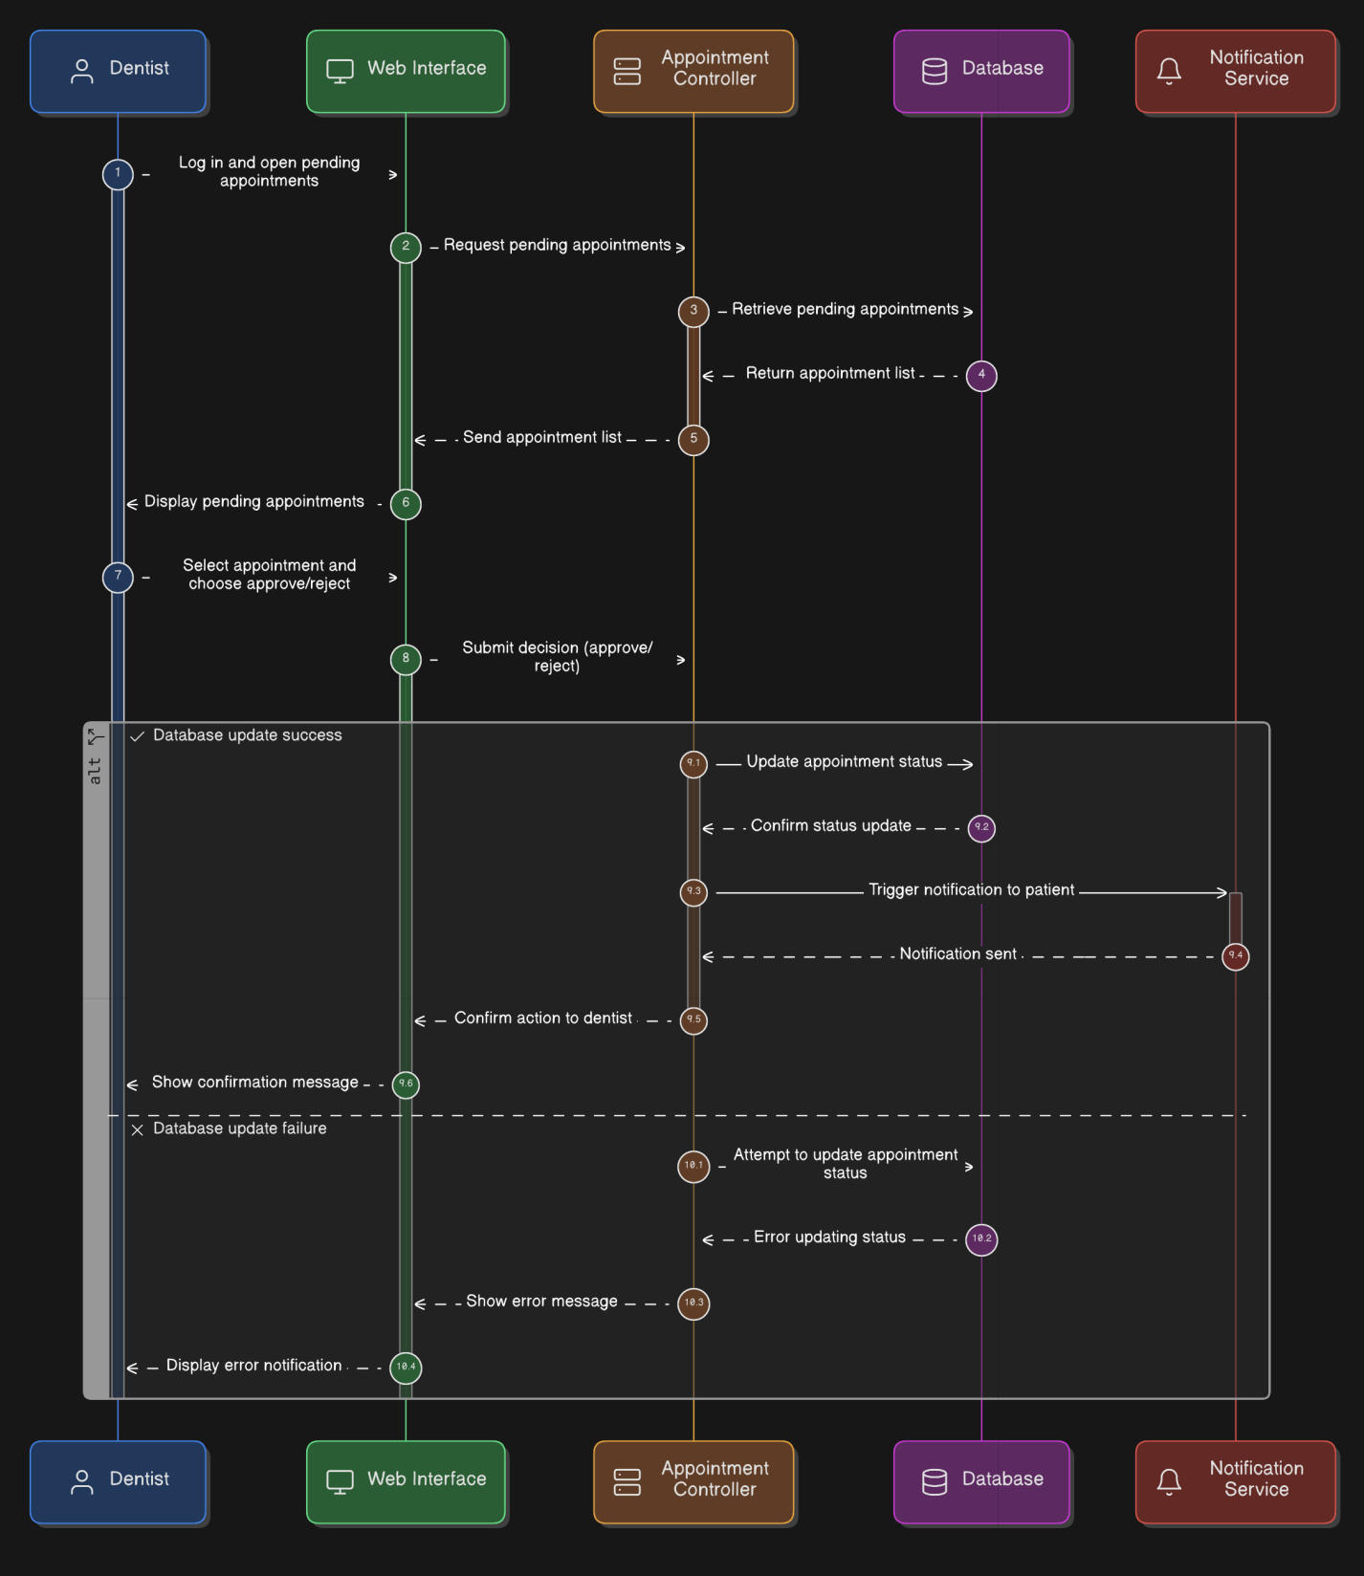

Figure 2.7: Walk-in Patient Registration Sequence Diagram
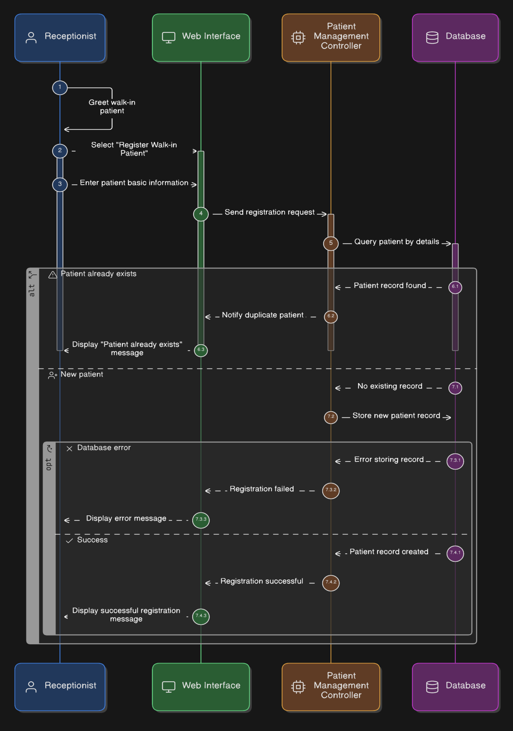

Figure 2.8: Appointment Completion Sequence Diagram
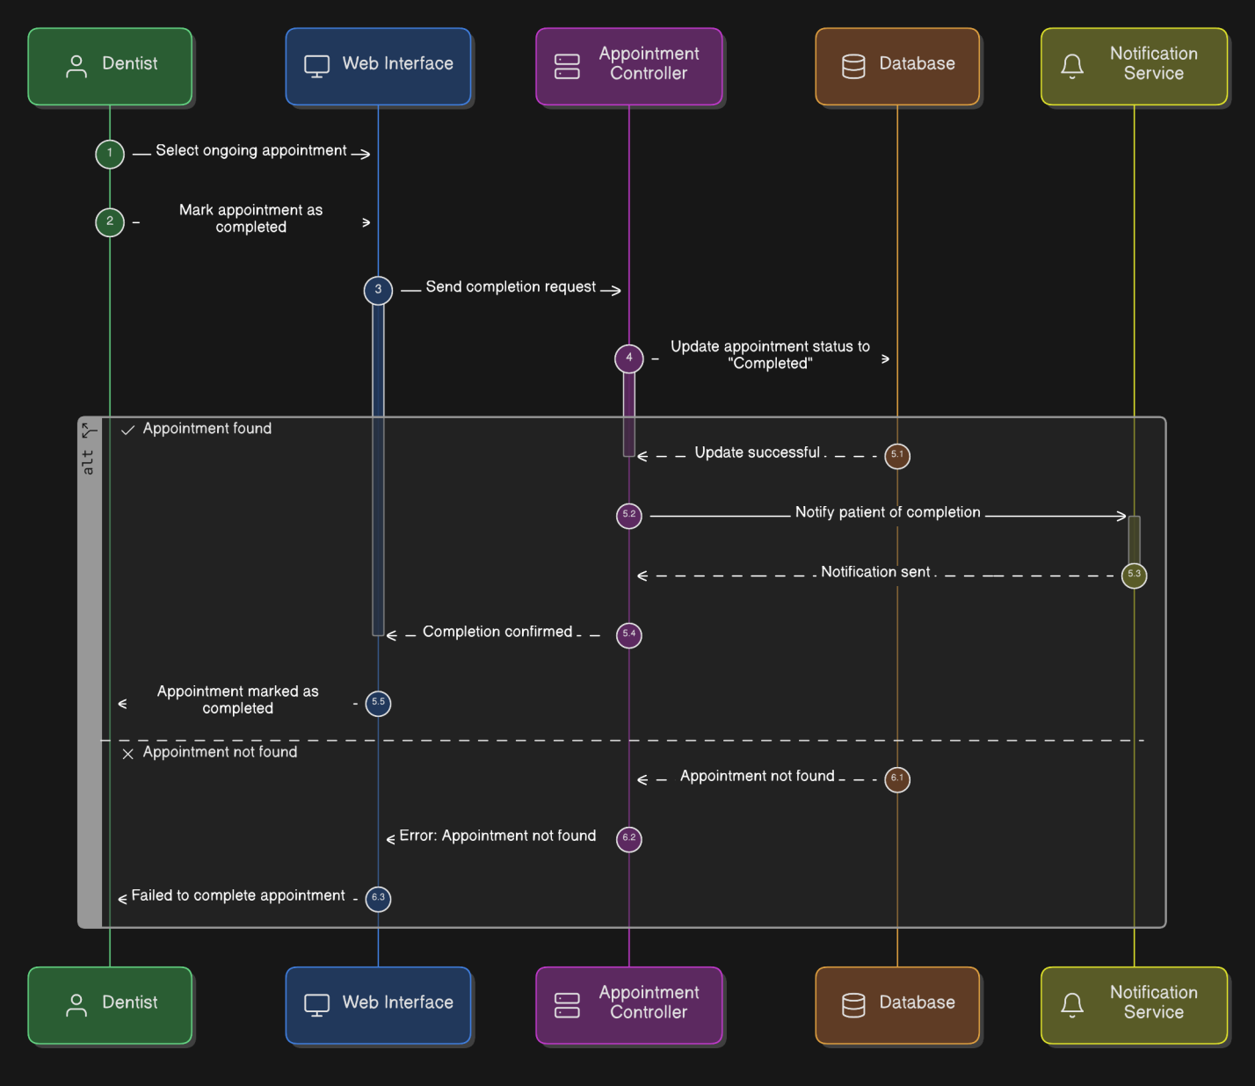

Figure 2.9: Staff Management (Admin) Sequence Diagram
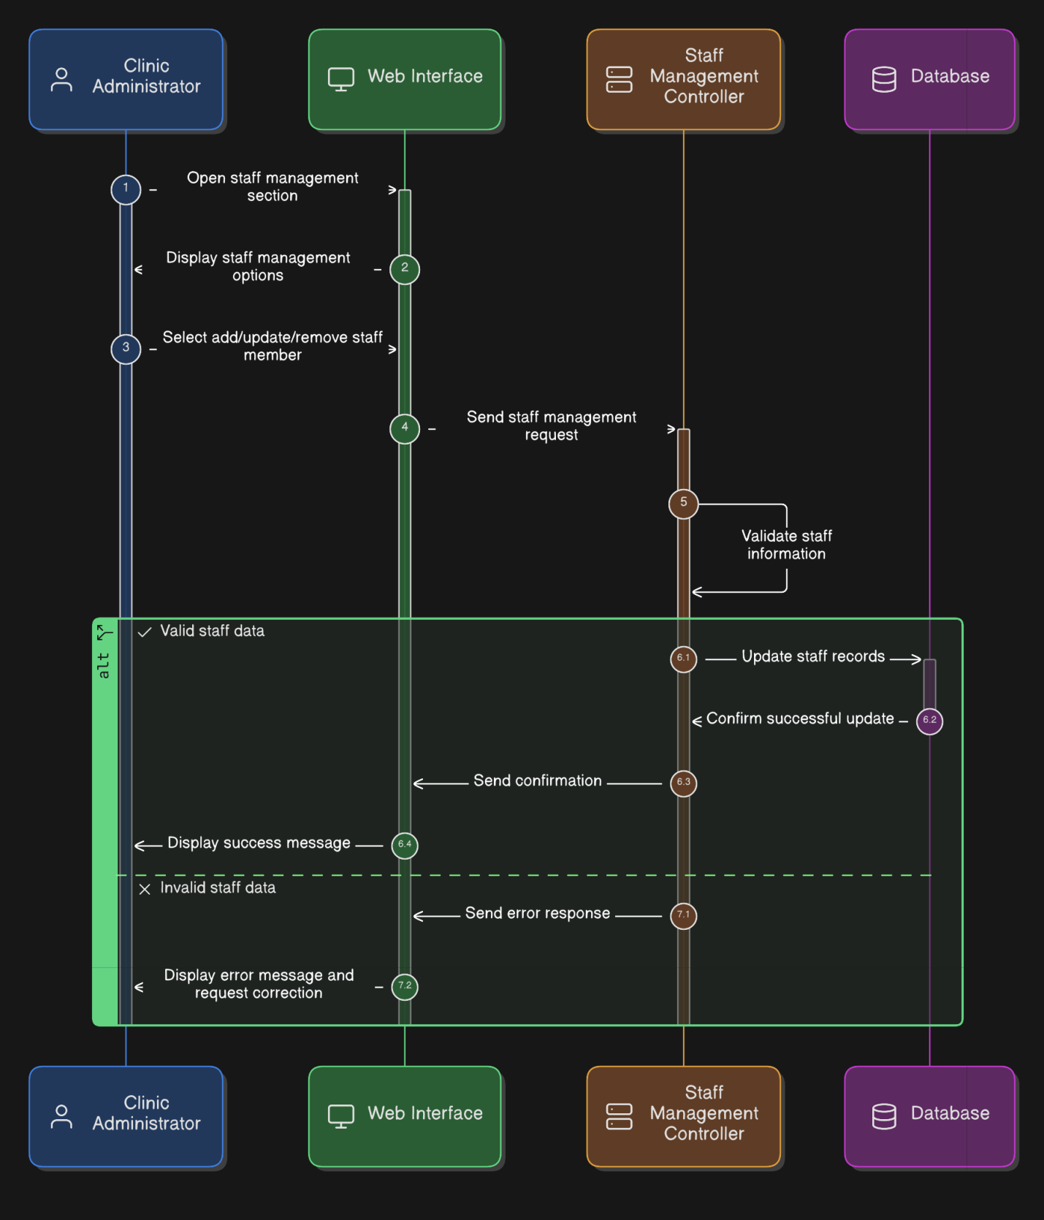

Activity Diagram
Activity diagrams are used to model the workflow and control flow of major system processes.
They show how activities are performed in sequence, including decision points, parallel actions, and termination states.
In this system, activity diagrams help visualize end-to-end business processes such as appointment booking, consultation flow, and administrative operations at a conceptual level.
Figure 2.10: Online Appointment Booking Activity Diagram
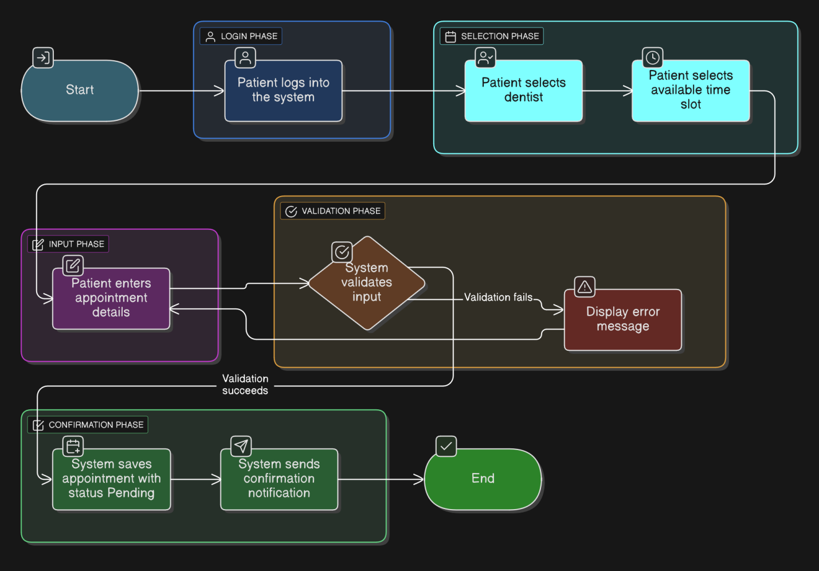

Figure 2.11: Walk-in Patient Registration Activity Diagram
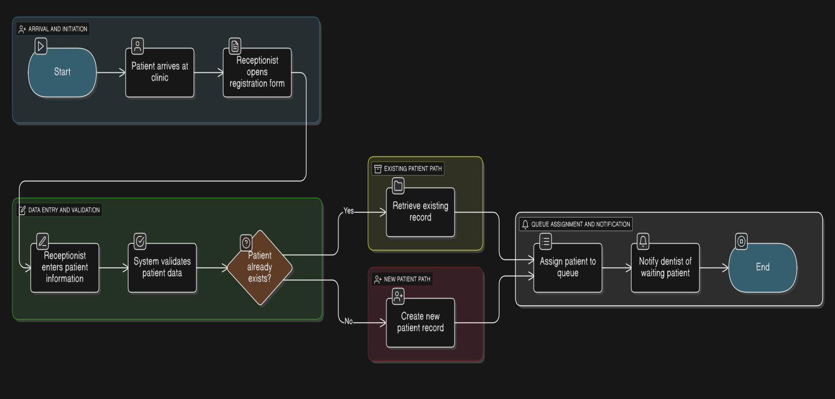

Figure 2.12: Appointment Approval & Scheduling (Dentist) Activity Diagram
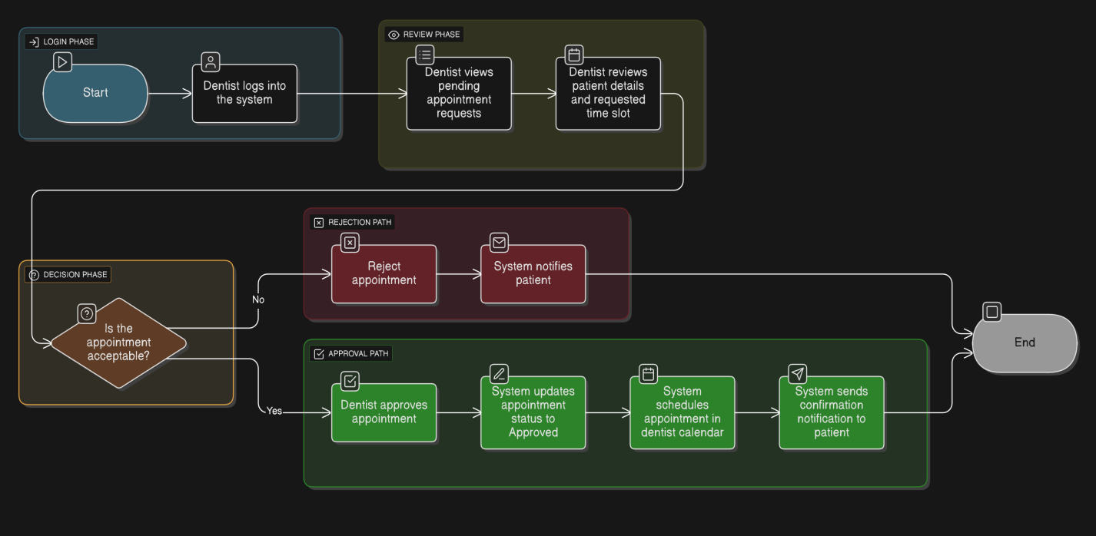

CHAPTER THREE: SYSTEM DESIGN

3.1 Introduction
This section presents the system design of the proposed web-based clinic management system for a private dental clinic. The purpose of system design is to translate the requirements identified in the Requirement Analysis phase (Section 2.3) into a well-structured and scalable software architecture that can guide implementation and future maintenance.
The system follows a modular, layered architecture that separates concerns across multiple subsystems, including user interface, application logic, data management, and security. The key design goals of the system include:
- Subsystem Decomposition:
Dividing the system into clearly defined subsystems such as presentation, backend services, database, and authentication to improve maintainability and scalability.
- Hardware/Software Mapping:
Designing the system to operate as a web-based application accessible via standard web browsers, with backend services hosted on a server environment and a centralized relational database.
- Persistent Data Management:
Ensuring reliable storage and retrieval of clinic data such as patients, appointments, consultations, prescriptions, and staff information using a relational database management system.
- Access Control and Security:
Enforcing role-based access control to protect sensitive medical and administrative data and ensure that users can only perform actions permitted by their role.
Additionally, this section provides traceability between system design decisions and the functional and non-functional requirements defined in the previous chapter. For example:
- The requirement for secure authentication and authorization directly influences the inclusion of an access control subsystem.
- The requirement for scalability and responsiveness impacts the choice of a client–server architecture and stateless backend services.
- Constraints such as limited hardware resources and web-only access shape the deployment and architectural style of the system.
Overall, the system design aims to produce a robust, secure, and extensible architecture that satisfies the operational needs of a private dental clinic while allowing for future enhancements.

3.2 Current Software Architecture
Currently, the private dental clinic operates using a largely manual or semi-digital system with no fully integrated software architecture. Core activities such as patient registration, appointment scheduling, queue management, and record keeping are typically handled through a combination of:
- Paper-based records
- Manual appointment books or spreadsheets
- Verbal communication between staff and patients
- Isolated digital tools without central integration
The existing approach lacks a unified architecture and does not provide:
- Centralized data storage
- Real-time appointment visibility
- Secure access control
- Automated notifications and reminders
- Integrated reporting or analytics
As a result, the current system is prone to errors, data redundancy, appointment conflicts, and inefficiencies in clinic operations. There is no formal software architecture being replaced; rather, the proposed system introduces a new, centralized web-based architecture designed to modernize and automate clinic operations.
The absence of an existing software architecture allows the proposed design to be developed without legacy system constraints, enabling the adoption of modern web technologies and best practices from the ground up.

3.3 Proposed Software Architecture

3.3.1 Overview
The proposed system adopts a three-tier web-based client–server architecture designed to support the operational and administrative needs of a private dental clinic. The architecture separates the system into clearly defined layers, each responsible for a specific set of functionalities. This separation improves scalability, maintainability, security, and performance.
The system consists of the following major layers:
- Presentation Layer (Client Side):
Implemented using Next.js with TypeScript/JavaScript and Tailwind CSS, this layer provides the user interface through which patients, dentists, receptionists, and administrators interact with the system using a web browser.
- Application Layer (Backend Services):
Implemented using Node.js with Express.js, this layer contains the business logic, request handling, validation, and access control mechanisms.
- Data Layer (Persistence Layer):
Implemented using PostgreSQL, this layer manages persistent storage of all clinic-related data, including patient records, appointments, consultations, prescriptions, staff accounts, and system configurations.
Each layer communicates through well-defined interfaces and APIs, ensuring loose coupling and ease of future extension.

3.3.2 Subsystem Decomposition
Subsystem decomposition divides the system into logical subsystems, each responsible for a specific domain of functionality. This modular structure enables independent development, testing, and maintenance.

Identified Subsystems and Responsibilities

User Interface Subsystem
- Provides web-based user interfaces for all user roles
- Handles user interactions and input validation at the client side
- Communicates with backend services via RESTful APIs
- Authentication and Authorization Subsystem
- Manages user login, logout, and session handling
- Implements role-based access control (RBAC)
- Ensures only authorized users can access protected resources
- Patient Management Subsystem
- Manages patient registration and profile updates
- Stores and retrieves patient demographic and medical data
- Provides patients access to their dental history
- Appointment Management Subsystem
- Handles appointment booking, rescheduling, cancellation, and approval
- Manages appointment statuses (pending, approved, completed, canceled)
- Integrates scheduling rules and clinic working hours
- Consultation and Treatment Subsystem
- Allows dentists to record diagnoses, treatments, and clinical notes
- Manages consultation history and treatment records
- Links consultations with appointments and patients
- Prescription and Recommendation Subsystem
- Enables dentists to issue digital prescriptions
- Stores medication details and follow-up recommendations
- Allows patients to view prescriptions online
- Queue and Reception Management Subsystem
- Supports walk-in patient registration
- Manages patient arrival and waiting queues
- Assists receptionists in daily clinic operations
- Notification Subsystem
- Sends appointment confirmations, reminders, and status updates
- Provides in-app notifications to users
- Supports automated alerts for important system events
- Administration Subsystem
- Manages staff accounts and roles
- Configures clinic settings such as working hours and holidays
- Provides dashboards and statistical summaries

Figure 3.1: Subsystem Decomposition
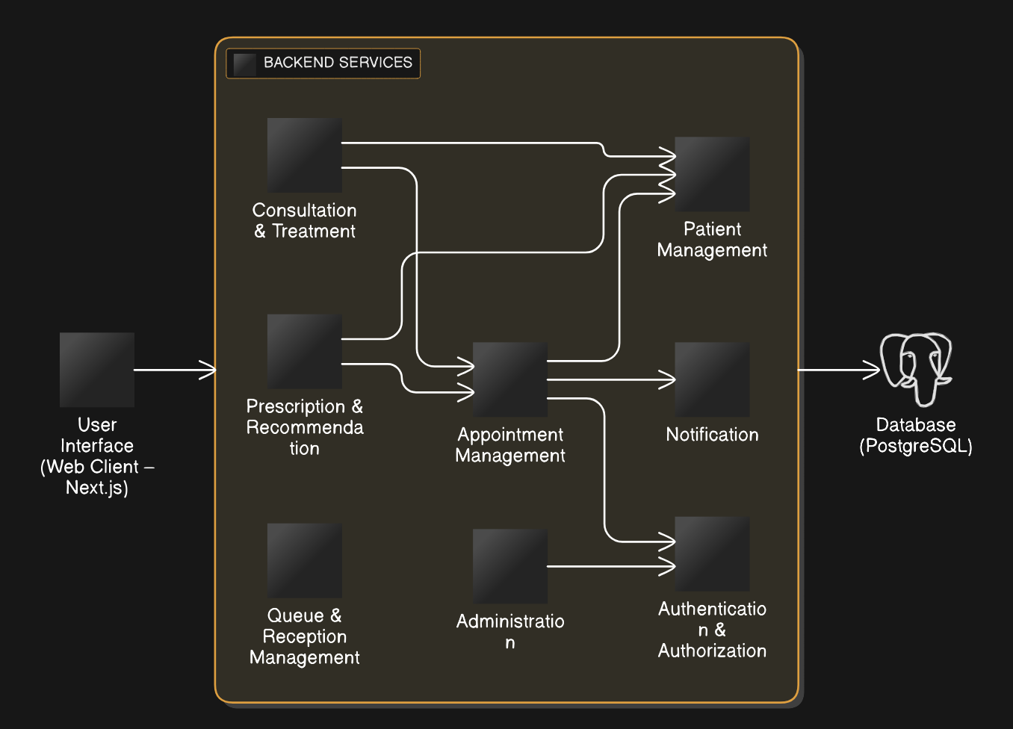

3.3.3 Hardware/Software Mapping
The hardware/software mapping defines how the software subsystems are deployed onto physical and logical hardware components.
Client Devices:
- Desktop computers, laptops, tablets, or smartphones
- Access the system via modern web browsers
- No additional software installation required
Web/Application Server:
- Hosts the backend application built with Node.js and Express.js
- Processes API requests, business logic, and authentication
- Communicates with the database server securely
Database Server:
- Hosts PostgreSQL relational database
- Stores all persistent clinic and system data
- Ensures data integrity and backup support
Optional Notification Services:
- External services (email or SMS gateways) may be integrated for reminders
Figure 3.2: Hardware/Software Mapping
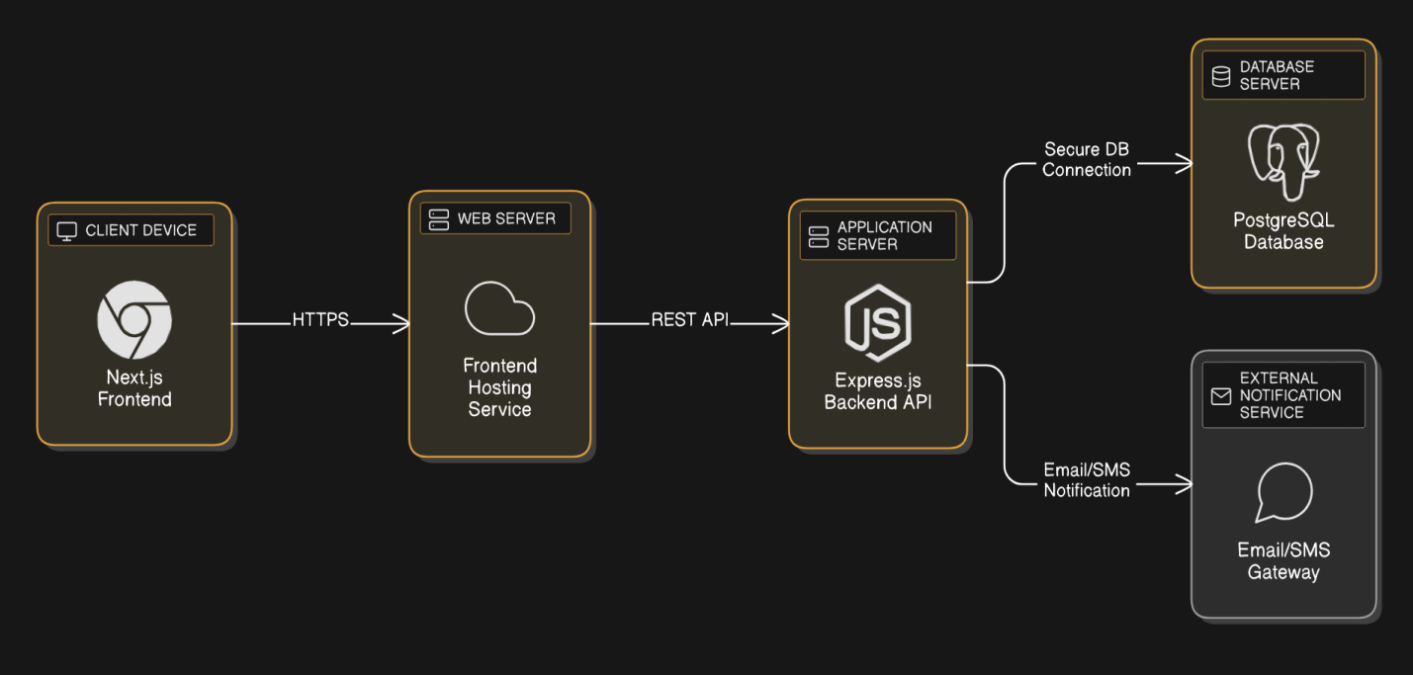

3.3.4 Persistent Data Management
The system uses a relational database management system (PostgreSQL) to store persistent data required for clinic operations.

Stored Data Includes:
- Patient profiles and contact information
- Staff and user accounts
- Appointments and scheduling data
- Consultation records and treatment notes
- Prescriptions and recommendations
- System configuration settings

Database Design Approach:
- Data is structured into normalized tables
- Relationships are enforced using primary and foreign keys
- Transactions ensure consistency during critical operations
- Access to the database is encapsulated within backend services to prevent direct client access

Figure 3.3: Persistent Data Management
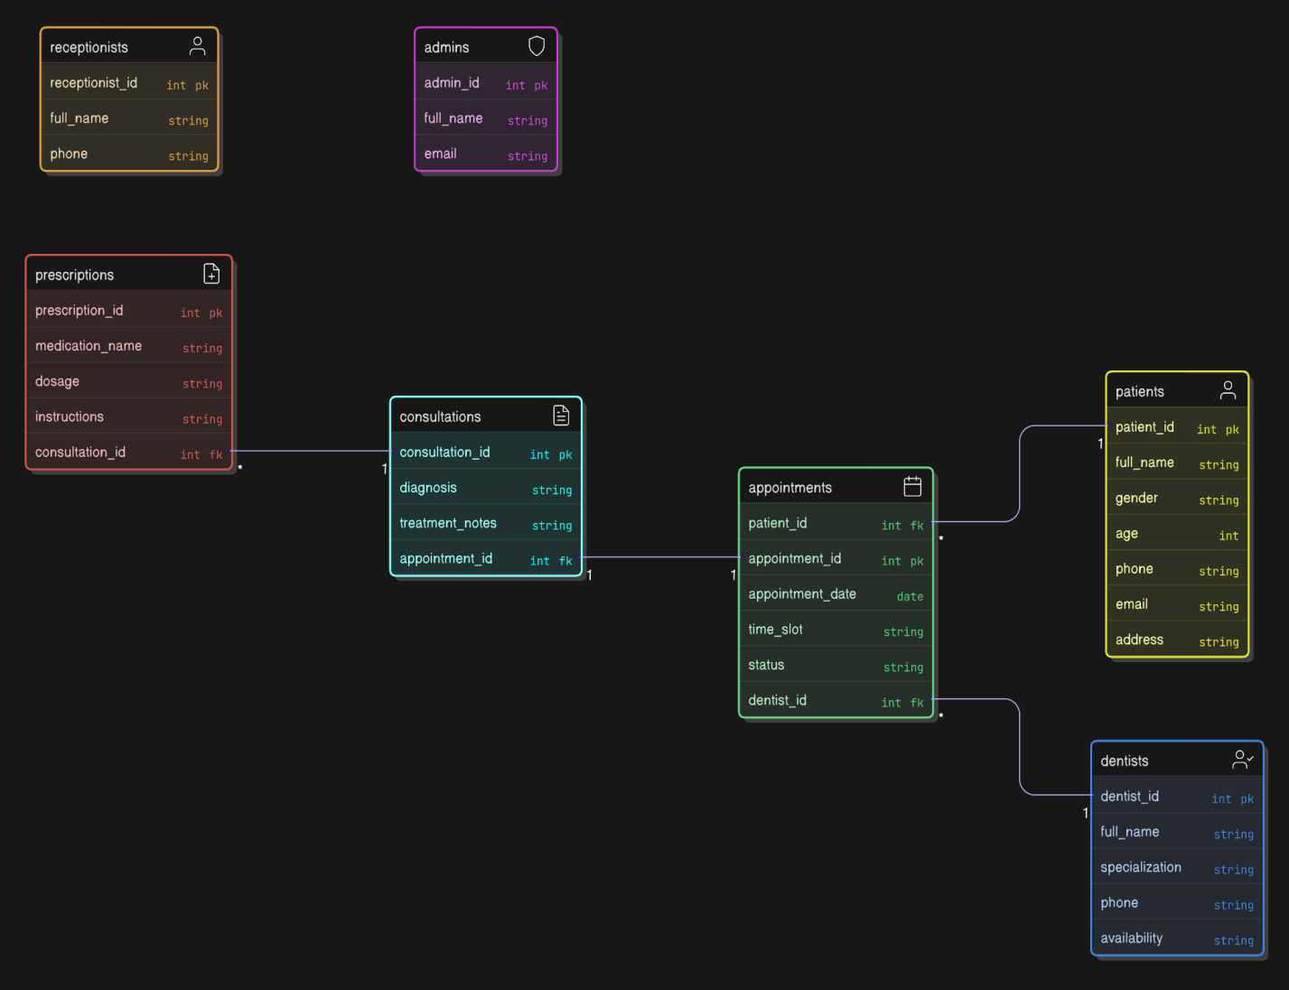

3.3.5 Access Control and Security
The system enforces role-based access control (RBAC) to protect sensitive information and restrict system actions.

User Roles:
- Patient
- Dentist
- Receptionist
- Administrator
Each role is granted specific privileges based on operational requirements. Examples include:
- Patients can book appointments and view their records
- Dentists can approve appointments and record treatments
- Receptionists manage queues and walk-in registrations
- Administrators manage staff and system configurations

Security Mechanisms:
- Secure authentication using username/email and password
- Encrypted password storage (hashing)
- Token-based authentication for API access
- HTTPS communication to protect data in transit

3.3.6 Subsystem Services
Each subsystem provides a set of services to support system functionality.
Table 3.1: Subsystem Services
Subsystem | Provided Services
User Interface | User interaction, form submission, data display
Authentication | Login, logout, role validation
Patient Management | Register patient, update profile, view records
Appointment Management | Book, approve, reschedule, cancel appointments
Consultation Management | Record diagnosis and treatment
Prescription Management | Create and view prescriptions
Queue Management | Register walk-ins, manage waiting lists
Notification | Send reminders and alerts
Administration | Manage staff, configure clinic, view dashboards

3.4 Packages
This section describes the decomposition of the system into packages and the organization of source code files. The package design groups related classes, services, and modules into cohesive units, thereby improving modularity, maintainability, scalability, and team collaboration.
The package structure is derived directly from:
- The subsystem decomposition (Section 2.4.3.2),
- The detailed class design (Section 2.4.4), and
- The selected technology stack (Next.js frontend, Express.js backend, PostgreSQL database).
Each package encapsulates a specific responsibility and exposes only well-defined interfaces to other packages.

3.4.1 Package Decomposition Overview
The system is organized into the following major packages:
- ui
- auth
- user
- appointment
- consultation
- prescription
- notification
- queue
- admin
- config
- common
- database
These packages collectively implement all core and advanced functionalities of the Dentist Appointment and Management System.

3.4.2 Package Descriptions and Responsibilities
1. ui Package
Description:
- Contains all user interface components responsible for interacting with users through the web browser.
Responsibilities:
- Patient, dentist, receptionist, and admin dashboards
- Forms for registration, login, and appointment booking
- Display of schedules, notifications, and medical records
Technology Mapping:
- Next.js pages, components, layouts, and Tailwind CSS styles.
Dependencies:
- Depends on auth, appointment, consultation, and notification packages via API calls.
2. auth Package
Description:
- Handles authentication and authorization logic.
Responsibilities:
- User login and logout
- Role-based access control (RBAC)
Token/session validation
- Key Classes/Services:
- AuthenticationService
- AuthorizationMiddleware
Dependencies:
- Depends on user and database packages.
3. user Package
Description:
- Manages user-related data and behavior.
Responsibilities:
- Patient, dentist, receptionist, and admin profiles
- Profile updates and retrieval
- User role handling
Key Classes:
- User
- Patient
- Dentist
- Receptionist
- Admin
Dependencies:
- Depends on database and common packages.
4. appointment Package
Description:
- Manages appointment scheduling and lifecycle.
Responsibilities:
- Appointment booking, rescheduling, cancellation
- Appointment approval and status updates
- Emergency appointment handling
Key Classes/Services:
- Appointment
- AppointmentService
Dependencies:
- Depends on user, notification, and database packages.
5. consultation Package
Description:
- Manages dental consultation records.
Responsibilities:
- Recording diagnosis and treatment notes
- Linking consultations to appointments
- Retrieving patient dental history
Key Classes:
- Consultation
Dependencies:
- Depends on appointment, user, and database packages.
6. prescription Package
Description:
- Handles digital prescriptions and follow-up recommendations.
Responsibilities:
- Creating prescriptions
- Storing dosage and instructions
- Making prescriptions available to patients
Key Classes:
- Prescription
Dependencies:
- Depends on consultation and database packages.
7. notification Package
Description:
- Manages system-generated notifications.
Responsibilities:
- Appointment reminders
- Status update notifications
- In-app notification delivery
Key Classes:
- Notification
Dependencies:
- Depends on user and database packages.
8. queue Package
Description:
- Supports receptionist and clinic queue management.
Responsibilities:
- Walk-in patient registration
- Patient arrival tracking
- Queue forwarding to dentists
Dependencies:
- Depends on appointment, user, and database packages.
9. admin Package
Description:
- Handles clinic administration features.
Responsibilities:
- Staff management
- Clinic dashboard and statistics
- System oversight
Key Services:
- AdminService
Dependencies:
- Depends on user, appointment, and config packages.
10. config Package
Description:
- Manages clinic-level configuration settings.
Responsibilities:
- Working days and hours
- Appointment duration
- Holiday and emergency slot settings
Key Classes:
- ClinicConfiguration
Dependencies:
- Depends on database package.
11. common Package
Description:
- Provides shared utilities and definitions.
Responsibilities:
- Enumerations (roles, statuses)
- DTOs and validation schemas
- Utility and helper functions
Dependencies:
- Independent; reused by all other packages.
12. database Package
Description:
- Encapsulates database access logic.
Responsibilities:
- Database connection handling
- Query execution
- Transaction management
Technology Mapping:
- PostgreSQL with ORM or query builder.
Dependencies:
- Independent; used by all backend packages.

3.4.3 Package Dependencies Summary
- High-level packages (ui, admin) depend on lower-level service packages
- No circular dependencies are allowed
- Database access is centralized through the database package
- Shared logic is isolated in the common package
This structure ensures low coupling and high cohesion, which is essential for long-term system maintenance.

3.4.4 UML Package Diagram Representation
Figure 3.4: Package Diagram
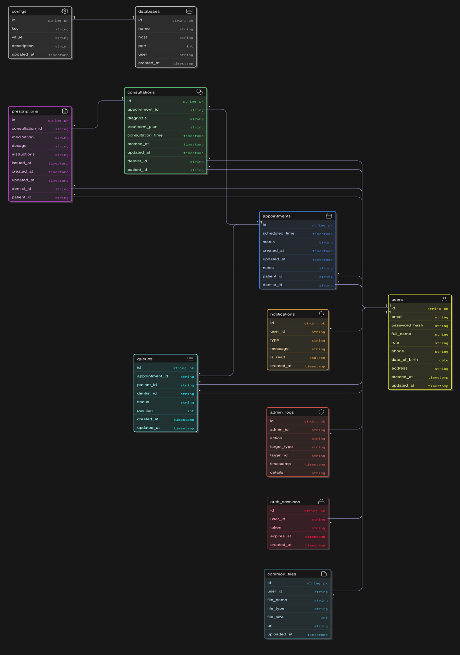

CONCLUSION AND RECOMMENDATION

Conclusion
This project successfully designed and documented a Dentist Appointment and Management System that addresses the key challenges of manual appointment handling, patient record management, and clinic administration. The system was developed following software engineering best practices, starting from requirement analysis and progressing through modeling, system design, and implementation.
The objectives defined at the beginning of the project have been fully achieved, including:
- Designing a role-based appointment management system for patients, dentists, receptionists, and administrators.
- Providing efficient appointment booking, approval, rescheduling, and emergency handling mechanisms.
- Supporting consultation recording, prescriptions, notifications, and queue management.
- Ensuring data persistence, security, and access control through well-defined architecture.
- Establishing strong traceability between requirements, UML models, design artifacts, and implementation.
The use of UML diagrams (use case, class, sequence, activity, component, deployment, and ER diagrams) helped ensure clarity, consistency, and correctness throughout the system design process. The layered architecture promotes scalability, maintainability, and extensibility, making the system suitable for real-world clinic environments.

Recommendations and Future Enhancements
Although the current system fulfills all identified requirements, several enhancements can further improve its effectiveness:
- Integration with Mobile Applications
- Development of Android and iOS applications to improve accessibility for patients and staff.
- Online Payment Integration
- Adding secure payment gateways for consultation fees and treatments.
- Advanced Notification Services
- Integration with SMS and email services for appointment reminders and emergency alerts.
- Analytics and Reporting
- Inclusion of advanced analytics dashboards to analyze patient trends, appointment patterns, and clinic performance.
- AI-Based Appointment Optimization
- Use of artificial intelligence to recommend optimal appointment slots and predict no-show probabilities.
- Integration with National Health Systems
- Interoperability with government or hospital health information systems for unified patient records.
These enhancements would further improve the system’s usability, reliability, and impact on healthcare service delivery.

References
[1] I. Sommerville, Software Engineering, 10th ed. Boston, MA, USA: Pearson Education, 2016, ch. 1–4, pp. 1–120.
[2] R. S. Pressman and B. R. Maxim, Software Engineering: A Practitioner’s Approach, 8th ed. New York, NY, USA: McGraw-Hill Education, 2015, ch. 3–6, pp. 55–210.
[3] IEEE Computer Society, IEEE Standard for Software Requirements Specifications, IEEE Std 830-1998, New York, NY, USA, 1998.
[4] Object Management Group (OMG), Unified Modeling Language (UML) Specification, Version 2.5.1, Needham, MA, USA, 2017.
[5] M. Fowler, UML Distilled: A Brief Guide to the Standard Object Modeling Language, 3rd ed. Boston, MA, USA: Addison-Wesley, 2004.
[6] T. H. Cormen, C. E. Leiserson, R. L. Rivest, and C. Stein, Introduction to Algorithms, 3rd ed. Cambridge, MA, USA: MIT Press, 2009.
[7] R. K. Aggarwal and M. Dave, “Acoustic modeling problem for automatic speech recognition system: conventional methods (Part I),” in International Journal of Speech Technology, vol. 14, no. 4, pp. 297–308, Springer Science+Business Media, 2011.
[8] S. T. Abate and W. Menzel, “Syllable-Based Speech Recognition for Amharic,” in Proceedings of the 5th Workshop on Important Unresolved Matters, pp. 33–40, Association for Computational Linguistics, Prague, Czech Republic, 2007.
[9] OWASP Foundation, 2023, OWASP Top Ten Web Application Security Risks [Online]. Available: https://owasp.org/www-project-top-ten/ [Accessed: Jan. 10, 2026].
[10] Oracle Corporation, 2024, PostgreSQL Documentation [Online]. Available: https://www.postgresql.org/docs/ [Accessed: Jan. 12, 2026].
[11] Mozilla Developer Network (MDN), 2024, Web Application Architecture [Online]. Available: https://developer.mozilla.org/ [Accessed: Jan. 14, 2026].
[12] IEEE Computer Society, IEEE Standard Glossary of Software Engineering Terminology, IEEE Std 610.12-1990, New York, NY, USA, 1990.

GLOSSARY
Term | Description
UML | Unified Modeling Language used for visualizing and designing software systems
Use Case | A functional requirement describing how users interact with the system
Actor | An external entity (user or system) that interacts with the system
Appointment | A scheduled meeting between a patient and a dentist
Consultation | A clinical interaction where diagnosis and treatment are recorded
Prescription | A digital medical instruction issued by a dentist
ER Diagram | Entity–Relationship diagram used to model database structure
Component Diagram | UML diagram showing software components and their dependencies
Deployment Diagram | UML diagram illustrating hardware and software mapping
Authentication | Process of verifying a user’s identity
Authorization | Process of granting access rights based on roles
CRUD | Create, Read, Update, Delete operations
API | Application Programming Interface
Role-Based Access Control (RBAC) | Security mechanism restricting access based on user roles

